**Step 1 : create a docker volume**

## Create and manage volumes

Unlike a bind mount, you can create and manage volumes outside the scope of any container.

**Create a volume**:

$ docker volume create data-volume

**List volumes**:

$ docker volume ls

**Inspect a volume**:

$ docker volume inspect data-volume

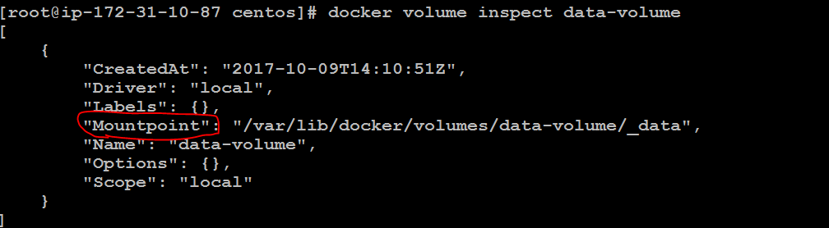

**Remove a volume**:

$ docker volume rm data-volume



**Step 2 : create a container with volume**

docker run -d -it --name web-host -v myvol2:/data ubuntu:16.04

////Notes

**Myvol2 : is created on the host id doenot exist**

**/data : is created in container if does not exist**

**docker volume ls**

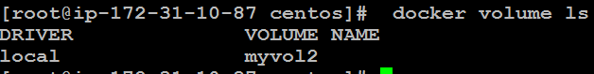

**docker volume inspect myvol2**

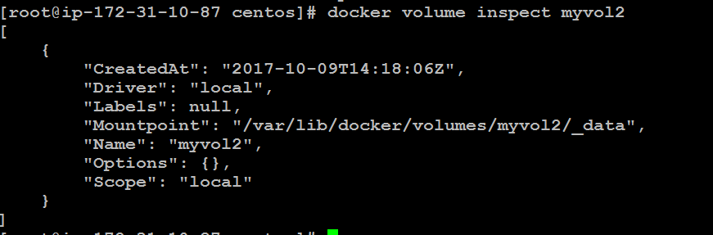

**Step 3 : login to container and touch a file**

$ docker exec -it web-host /bin/bash

**Step 4 : create new new file in the /data directory and exit container**

.

touch data/anil.txt

ls data/

exit

**Step 5 : validate if file is there on your existing host file system**

ls -l /var/lib/docker/volumes/myvol2/_data

**Step 6 : remove the web-host container and create a new container**

docker rm -f web-host

docker run -d -it --name new-host -v myvol2:/data ubuntu:16.04

**Step 7 : login to container and touch a file**

docker exec -it new-host ls -l /data

